Experiment 6: Vacuum Cleaner Problem

AIM
To develop a Python program to solve the Vacuum Cleaner Problem using a simple intelligent agent.

OBJECTIVE
To demonstrate how a vacuum cleaner agent senses the environment and cleans all dirty rooms efficiently.

ALGORITHM
- Start.
- Initialize the environment with the room locations and their status (Clean/Dirty).
- Sense the current room and clean it if it is dirty; otherwise, move to the next room.
- Repeat the process until all rooms are clean.
- Display the final room status and
- Stop.

SAMPLE CODE
def vacuum_cleaner(rooms):
for room in rooms:
if rooms[room] == "Dirty":
print(room, "is Dirty")
print("Cleaning", room)
rooms[room] = "Clean"
else:
print(room, "is already Clean")

print("\nFinal Room Status:")
for room in rooms:
print(room, ":", rooms[room])
rooms = {
"Room A": "Dirty",
"Room B": "Dirty"
}
vacuum_cleaner(rooms)

FLOW CHART
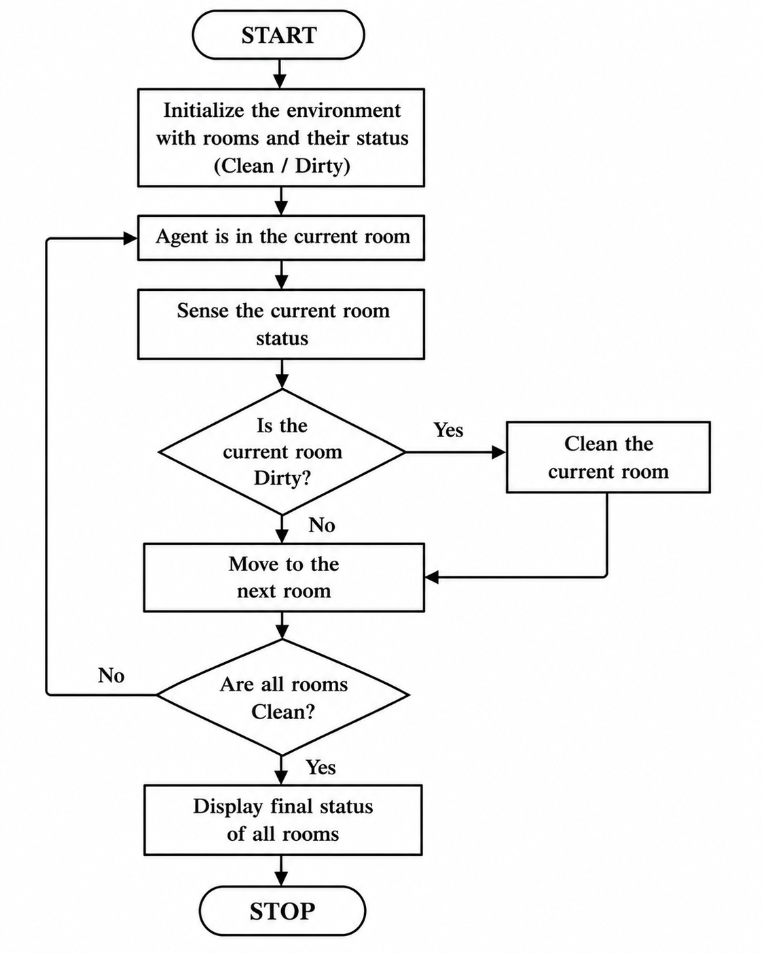
OUTPUT
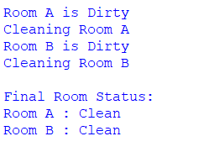
RESULT
The Python program was executed successfully. The vacuum cleaner agent sensed the environment, cleaned all the dirty rooms, and displayed the final status of each room.

